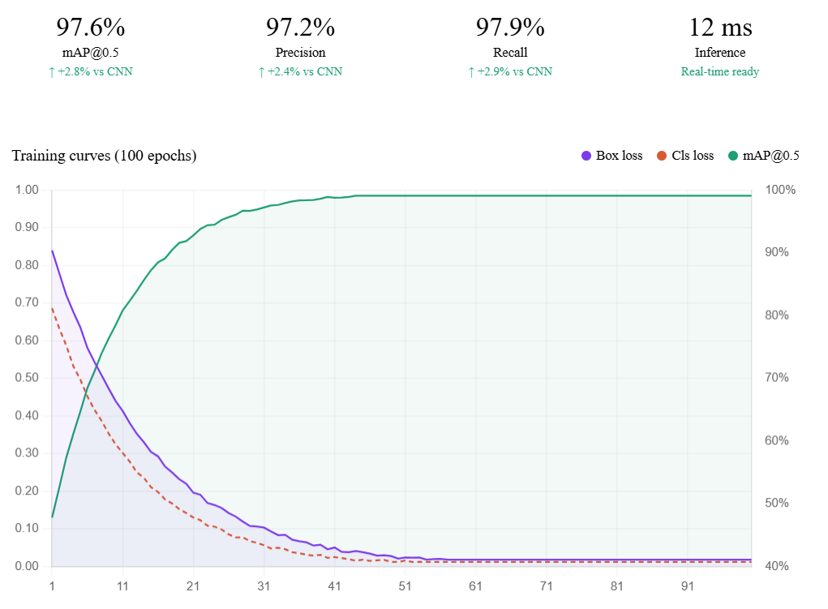

Graph.1. Training curves showing box loss, classification loss, and mAP@0.5 of the model over 100 epochs.

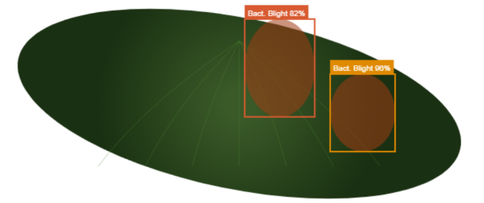

Fig. 1 the disease detection result of the model on a leaf image. Shows the model correctly identifies the bacterial blight–affected regions and marks them with bounding boxes and confidence scores.

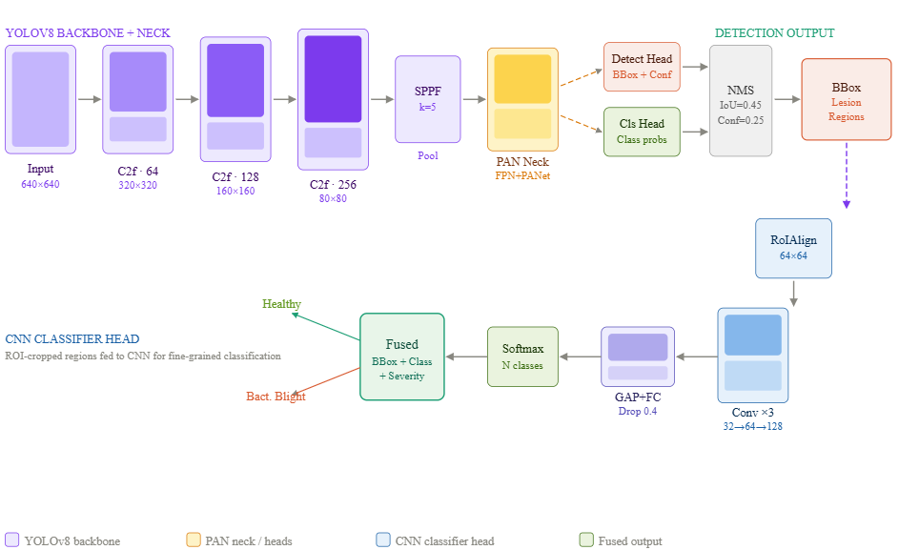

Fig.2illustrates the YOLOv8 + CNN architecture for crop disease detection. YOLOv8 detects the infected leaf regions, while the CNN performs detailed disease classification to produce the final prediction.

